**How does the config file work?**

1. Go to the folder where frontend files are located (eth-mike-frontend)
2. Choose config.json and open with notepad ++ or other text editor (Visual studio is slow)

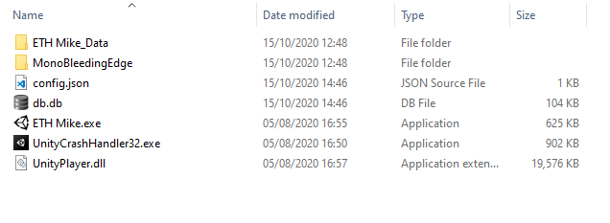

1. Inside this config you can now select preset configuration (e.g. “ksa_longitudinal_mike3”), the idea is to have one file like this for each study/ testing environment / device. The pre-set configs are located in ETH Mike_Data 🡪 StreamingAssets 🡪 ConfigPresets

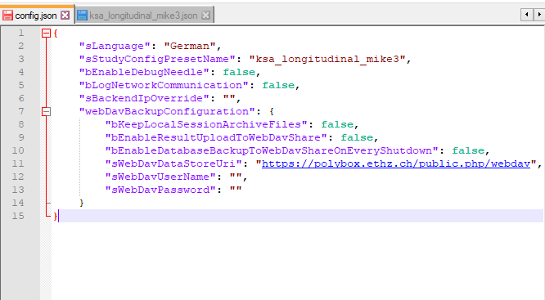

1. Inside the pre-set config (here “ksa_longitudinal_mike3”) we define the things that are specific to this configuration (here study name, how are we connecting with backend, which scene, which tasks, ftp download method)

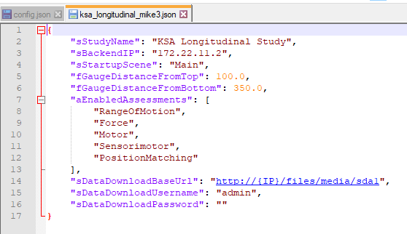

1. Things that are not defined in this “ksa_longitudinal_mike3” file are taken from default.json, which is stored in the same location as all the pre-set configs. For example number of trials is defined in the default.

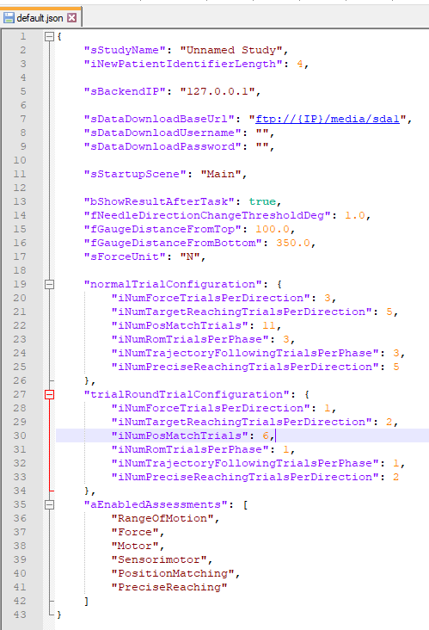

1. If you want to customize a config preset where some settings are missing, you can copy them from default.json and add them to the config preset (in this example – “ksa_longitudinal_mike3.json”. Note: pay attention to trailing commas, json expects a comma between all elements and no comma after the last element. Alternatively, you can copy default.json, rename it (as in this example into e.g. “ksa_longitudinal_mike4”) and customize all the settings. The name you renamed it to needs to be inserted in sStudyConfigPresetName in the main config.json.
2. Explanation of what each field in the default.json is is located in **readme.txt** located in eth-mike-frontend 🡪 ETH Mike_Data 🡪 StreamingAssets 🡪 ConfigPresets